Fundamentals of OpenPLC
Contents
Introduction 1
Installation 1
Creating a Project 1
Creating a POU 1
Editor Key Components 1
Programming in Ladder Logic 1
Fundamentals 1
Designing a Program 1

Introduction
This document is to help assist you in the usage of OpenPLC Runtime and OpenPLC Editor. Particularly installation, project set up, various project components, and using the web application for real time monitoring. Be sure to follow along carefully, more information can always be found on OpenPLC’s website found here: https://autonomylogic.com.

Installation
OpenPLC is comprised of two main components, the editor, and runtime. The editor is used to make project files which can then be input into the runtime to allow for execution. If you’re familiar with programming, think of the editor as the integrated development environment (IDE) while the runtime is the compiler/terminal.
Installing OpenPLC Editor is a fairly simple process, simply download the installer from the link for your respective operating system; https://autonomylogic.com/download.
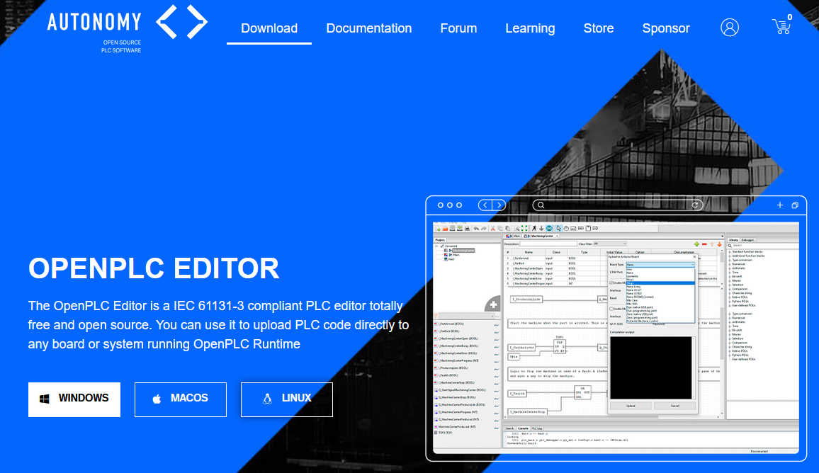
Figure 1 OpenPLC Editor download page
Download, open the installer, and select your preferences, then click install in the bottom right corner.
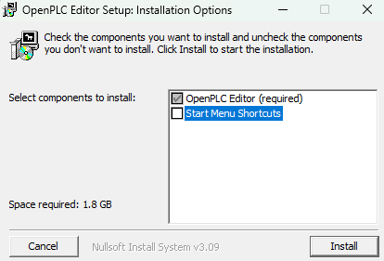
Figure 2 OpenPLC Editor installer wizard
Next let’s install OpenPLC Runtime, this process is a bit trickier. For this navigate to the following link, https://autonomylogic.com/docs/installing-openplc-runtime-on-windows/. There are two separate guides on Autonomy’s website, one for Linux, and one for Windows. For this tutorial we’ll primarily be focusing on Windows, but the process is relatively the same.
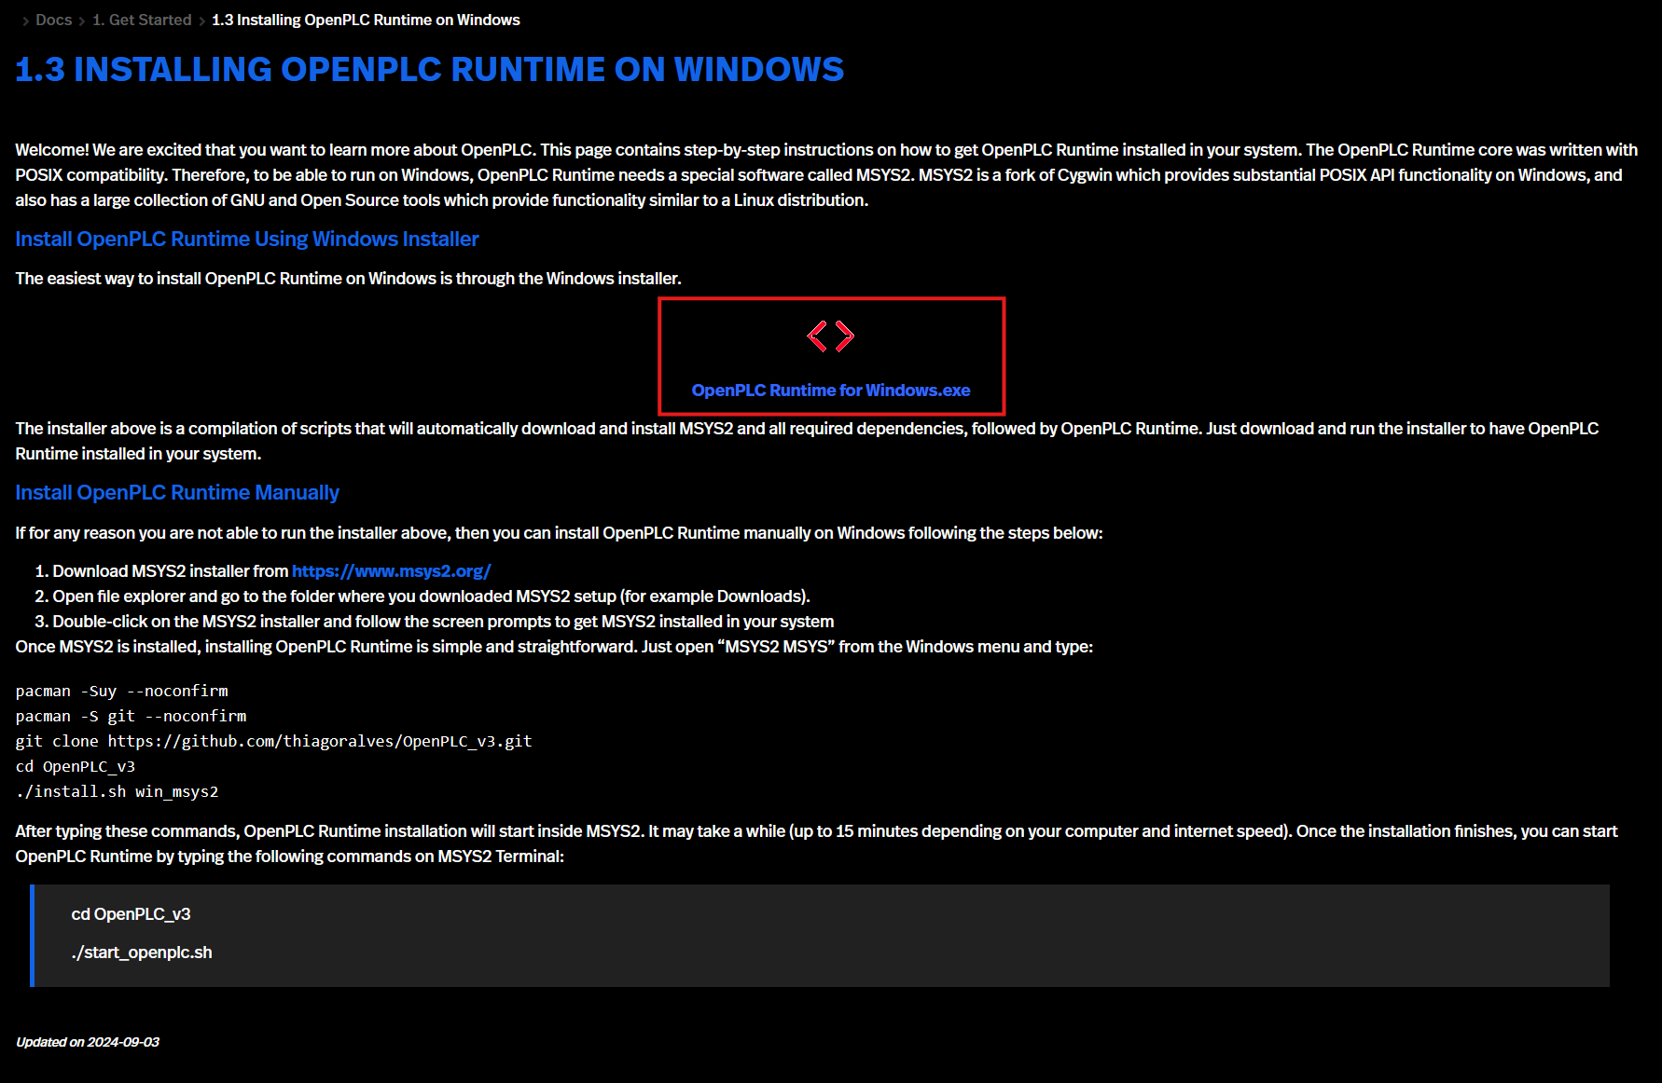
Figure 3 OpenPLC Runtime download page
Download, open the installer, and select your preferences, then click install in the bottom right corner.
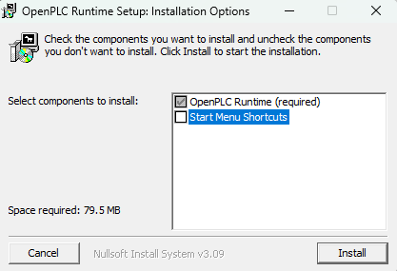
Figure 4 OpenPLC Runtime installer wizard
Now we have successfully installed both the Editor and the Runtime. Next let’s look at the OpenPLC Editor and make a sample project.

Creating a Project

Creating a POU
After installation of the OpenPLC editor, you will be able to start it from the start menu on your Windows machine. Once OpenPLC editor is open you should see the following window:
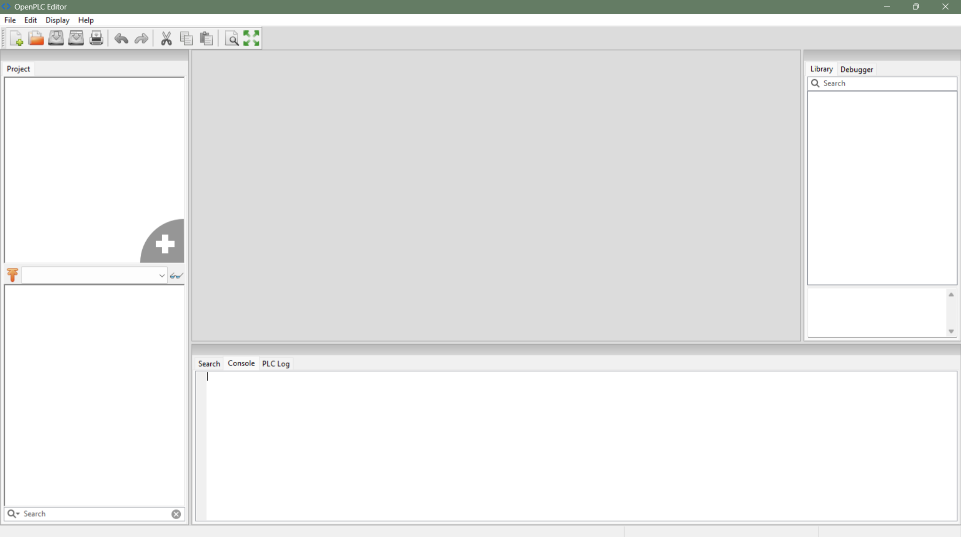
Currently no project is loaded, so let’s create one. Navigate to File -> New or press CTRL+N to create a new project.
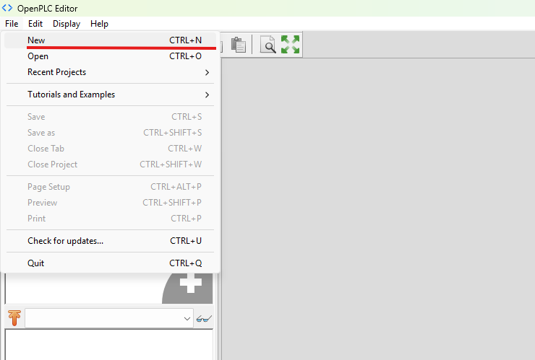
Next, select a new directory for your project, make sure this directory is empty.
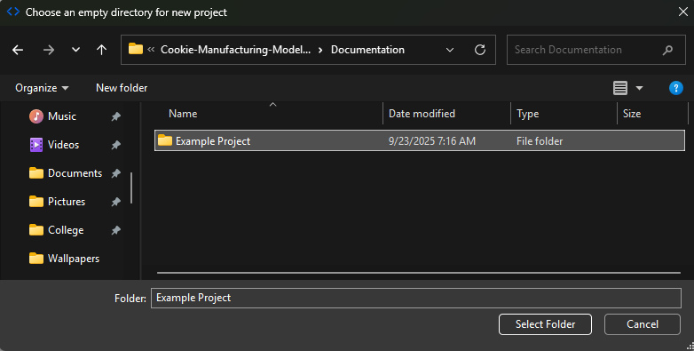
Next you should see a pop-up prompting you to create a program organization unit (POU), which is a building block defined by the IEC 61131-3 standard. A POU can be a program, function, or function block. Which are defined on OpenPLC’s website as the following:
- Program – application code combining inputs, outputs, functions and function blocks
- Function – reusable user code that has a return value
- Function Block – reusable user code that can retain its state (instance)
For the sake of this documentation, we will be creating one POU with ladder logic (LD) as our main program, which will later interface with a function block POU running on structured text (ST).
So, name your POU and select LD as your programming language in the popup, with the POU type as program. Then press OK. (Also ensure that your POU name contains no spaces).
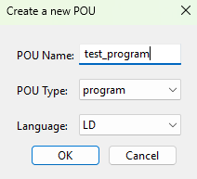

Editor Key Components
Now we should see our project open in the editor with our program we just created. Let’s go through the key components of the editor at this time so that we can familiarize ourselves with the software going forward.
First is the taskbar, this contains multiple useful tools that will be used throughout this document. As such I won’t go into too much detail explaining them but instead showing them.
Here is the project tree. This contains all our POU and a resource object that defines global variables and facilitates shared variable access between all of our POUs. We will see our function block appear here later in this documentation.
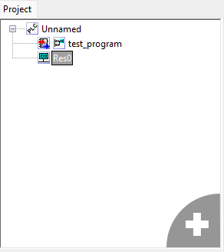
Next is the POU viewer/editor. At the top of this pane, we can see our variables associated with our program (this should be blank currently) and at the bottom we can a currently blank area, this area changes based on what programming language you choose for your POU. In our case it will eventually contain ladder logic.
Note the green plus in the top right corner as this will be used to add our variables in the future.
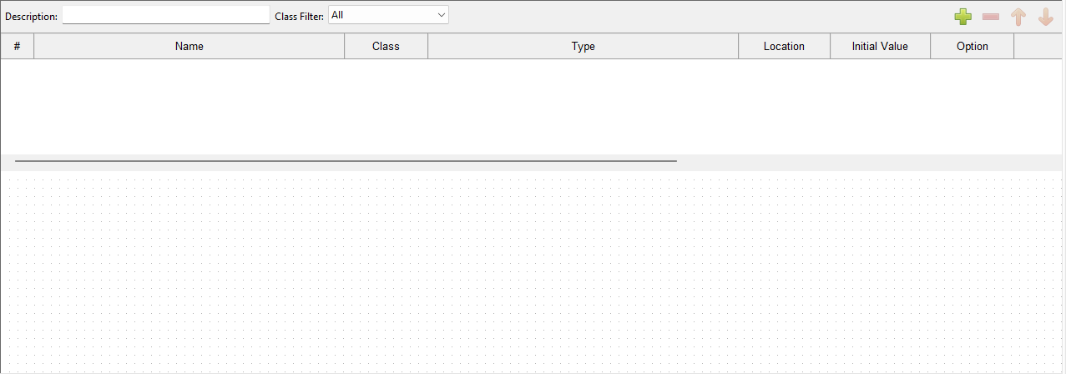
The library is to the left, as well as the debugger which we’ll be using later. The library can be used to quickly access all function block POUs including user defined ones, as we’ll show later.
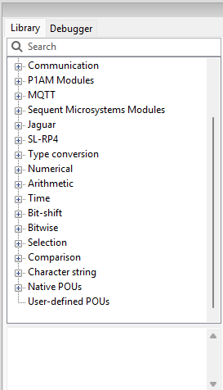
Next, we have the console which will show us the compilation results of our program. In this screenshot you can see I tried compiling the program, but since we have no variable defined it produced an error. Here’s where you’ll look to see if you have any issues with programming.
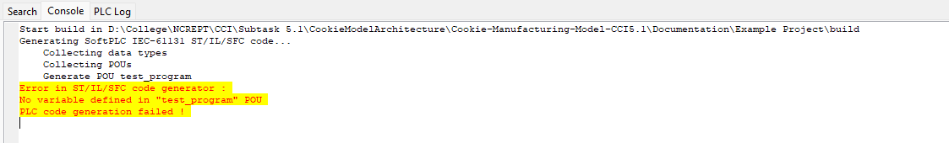
Finally, we have the instance pane which shows all the instances of variables or references in a POU, this will populate as we add variables to our program.
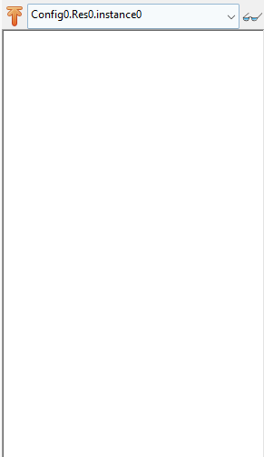

Programming in Ladder Logic
Now that we know the different tools located within the editor we can move on to the programming of our POU. But before that we need to understand the language we’re programming in.

Fundamentals
Execution:
- Programmable logic controllers are real time devices, meaning that they scan for inputs to produce outputs almost instantaneously. It’s because of this that ladder logic programs run constantly, in a loop and on a clock, to check inputs and change outputs.
Rungs:
- Every ladder logic program can be broken down into rungs which are executed from top to bottom.
- Rungs are effectively our lines of code, they act independently of one another unless they reference similar variables, and they execute from right to left.
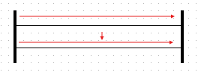
Figure 5 A set of empty rungs, the first rung is executed from right to left, followed by the second rung
Rungs by themselves do nothing, they are typically populated with Contacts and Coils.
Contacts:
- Contacts represent our input for any given rung. An open contact means the rung is allowed to execute until the next contact is reached, a closed contact means the rung is not allowed to execute.
- Contacts are tied to a Boolean variable that determines whether the contact is open or closed.
- Contacts also have modifiers which can be applied to change how the Boolean variable is processed.
  - Normal: The normal modifier simply maps the Boolean variable to the contact, if the variable is true the contact is closed and allows logic to continue, and vice versa.
  - Negated: The negated modifier is the same as the normal modifier except negated, if the variable is true the contact is open and halts logic, and vice versa.
  - Rising edge: The rising edge modifier opens the contact only if the variable is changing from false to true.
  - Falling edge: The falling edge modifier opens the contact only if the variable is changing from true to false.
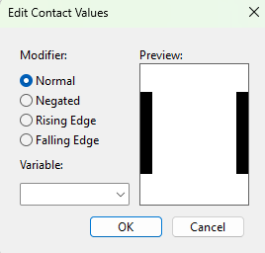
Figure 6 New contact menu with each modifier and a drop-down menu to select the associated variable
Coils:
- Coils represent our output for any given rung. Coils are only powered (by default) if each consecutive contact in a rung is closed.
- Coils are also tied to a Boolean variable that is set to true or false based on whether the Coil is powered on or off.
- Coils have modifiers as well which change how the Boolean variable is set.
  - Normal: The normal modifier maps the coil to a Boolean variable, if the coil is powered on, the Boolean variable is set to true, and vice versa.
  - Negated: The negated modifier is the same as the normal modifier except negated, if the coil is powered on, the Boolean variable is set to false, and vice versa
  - Set: The set modifier is like the normal modifier except that the Boolean variable stays true regardless of the contacts being opened or closed. A variable set to true in this way can only be set to false by using a coil with a reset modifier.
  - Reset: The reset modifier is used to set a Boolean variable to false after it was manipulated by a coil with a set modifier.
  - Rising edge: The rising edge modifier powers the coil only if its input is changing from false to true, that means the combined logic of all preceding contacts. Note: this also means that the coil is only powered on for effectively one pulse or scan of the PLC.
  - Falling edge: The falling edge modifier powers the coil only if its input is changing from true to false, that means the combined logic of all preceding contacts. Note: this also means that the coil is only powered on for effectively one pulse or scan of the PLC.
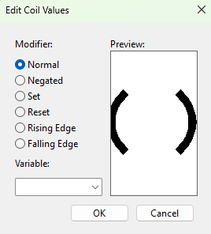
Figure 7 New coil menu with each modifier and a drop-down menu to select the associated variable

Designing a Program
Now that we understand the fundamentals of ladder logic lets design a small program using a single contact, a single coil, a single rung, and two variables. This program will emulate a light switch.
First begin by defining some variables. In the top left of the test program pane click the green plus sign twice to add two variables.
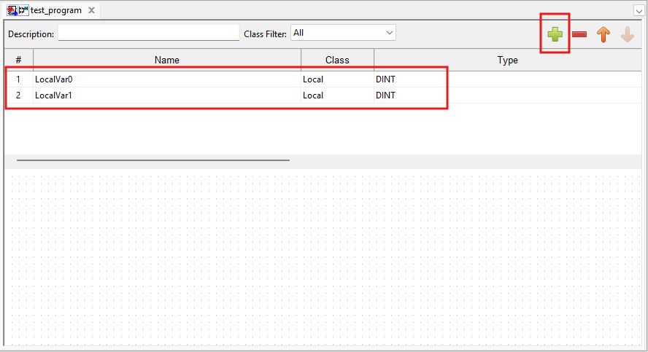
You should see two variables, LocalVar0 and LocalVar1. For this program we’ll go into their name, class, and type. Just know that you can edit it’s location in memory, it’s description, and it’s initial value.
Now let’s change their names, you can change the name of a variable by double clicking the name field. I’m changing the first variable name to SWITCH_0, and the second variable name to LED_0.
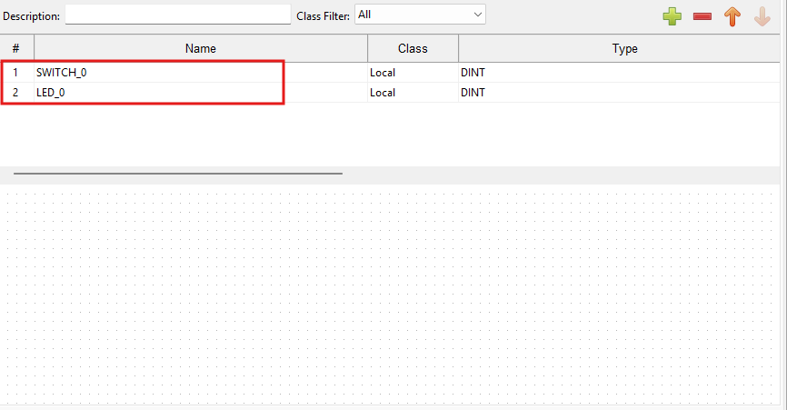
Now let’s change the type, we want these to be manipulated by coils and contacts, so they need to be Booleans. Let’s change the type to BOOL. Click the type of field and select Base Types->BOOL.
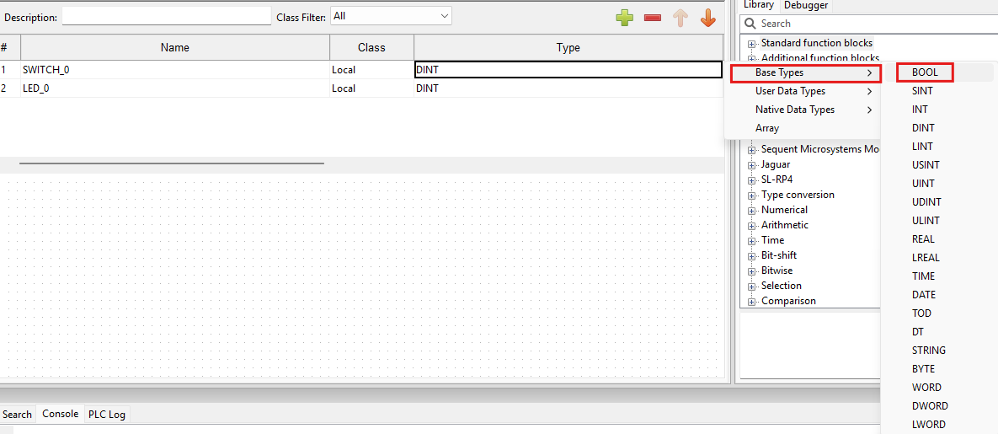
Now we should have
// TODO: Add rest of program example, go into function blocks, how to execute them on a rung, etc.

